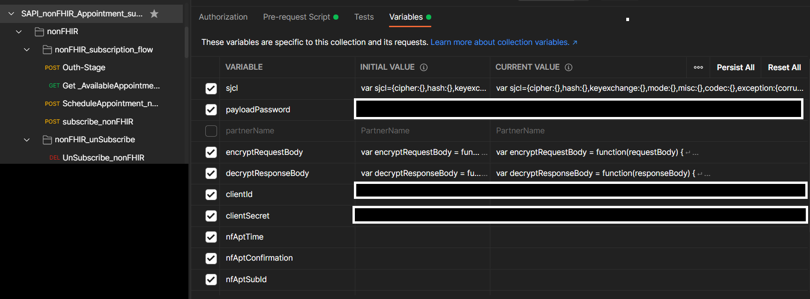
Collection should be updated with
collection variables:
1)clientId is okta id
2)clientSecret is okta secret
3)payloadPassword is payload encryption key
Environment variables:
Env variables
{{okta_Url_prefix}} | Okta url - QA | https://labcorp-holdings-qa.oktapreview.com/oauth2/default/v1/token
 | Okta url - stage | https://labcorp-holdings-stage.oktapreview.com/oauth2/default/v1/token
 | Okta url - Prod | https://labcorp-holdings.okta.com/oauth2/default/v1/token
{{sched_url_prefix}} | SAPI -url - QA | https://gw.scheduling-qa.dev.cws.labcorp.com
 | SAPI -url - stage | https://gw.scheduling-stg.dev.cws.labcorp.com
 | SAPI -url – Prod | https://gw.scheduling-prd.cws.labcorp.com

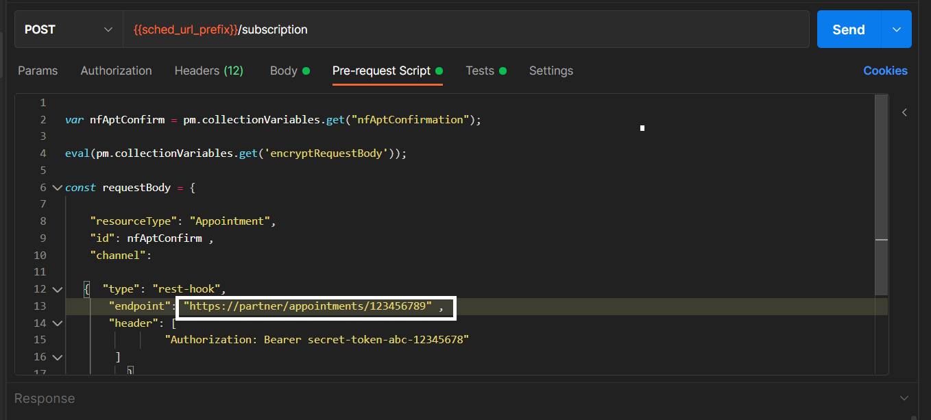
Note: The callback endpoint provided here is only a dummy endpoint. The endpoint will need to be replaced by the Partner's Notification API endpoint.

